**CS 1400 Fundamentals of Programming**

**Programming Project #5**

**Shipping Rates**

**Version 1.0**

**Objective:**

At the completion of this project, you will have created an application that

* gets input from the user,
* uses decision logic and numeric expressions, and
* formats the output in proper dollars and cents and displays it for the user.

**The Problem**

Red Fern On-Line Electronics has asked you to create a program for them that calculates the shipping rates for on-line purchases. The shipping rates are shown in the following table.

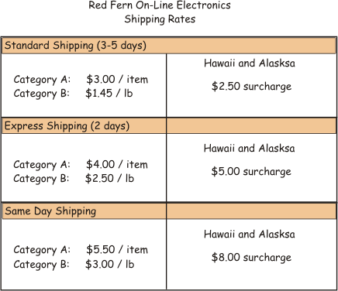

**The Program**

For this assignment you may create either a Console or a Graphical User Interface application. The following instructions describe how a Console application should work.

Your program should do the following:

1. Ask the user what shipping method to use (***Standard***, ***Express***, or ***1-Day***).
2. Get the user's input and stores it.
3. Ask the user if the items to be shipped are in ***Category A*** or ***Category B***. For the purpose of this exercise assume that all items shipped are in the same category.
4. Get the user's input and stores it.
5. If the items are in ***Category A***, ask how many ***items*** are in the shipment.
6. Get the user's input and stores it.
7. If the ***items*** are in ***Category B***, ask for the ***total weight*** of the shipment.
8. Get the user's input and stores it.
9. Ask if the shipment is going to ***Alaska*** or ***Hawaii***.
10. Get the user's input and stores it.
11. Calculates the total shipping cost using the table above.
12. Print out the total cost of shipping in the following formats (These are examples): Be sure to look at the sample output below.

|  |  |
| --- | --- |
| Standard Shipping, Category A, no surcharge       Standard Shipping      3 Items      Total Shipping Cost: $9.00 | Standard Shipping, Category B, no surcharge       Standard Shipping      24 lbs      Total Shipping Cost: $34.80 |
| Express Shipping, Category A with surcharge       Express Shipping      2 Items      surcharge $5.00      Total Shipping Cost: $13.00 | 1-Day Shipping, Category B, no surcharge       One Day Shipping      16 lbs      Total Shipping Cost: $48.00 |

For this program you should also worry about testing for invalid input values. Make sure that your program works for every valid and invalid input case. **Hint**: This program requires lots of decision logic, but don't get overwhelmed. Just take things a step at a time.

***Magic Numbers***

Be sure that your program does not contain any magic numbers!

**UML Activity Diagram and Pseudo-Code**

You will find it helpful to draw an Activity Diagram that illustrates the logic involved in the program. You do not need to turn in your Activity Diagram. However, use your Activity Diagram to create the Pseudo-Code for this program. Paste this Pseudo-Code into your Main method and make each line of Pseudo-Code a comment.

Format and document your code in accordance with the course Style Guidelines.  Include a Project and required method prologs.  Submit your project to Canvas.

**File(s) to Submit:**

Zip your entire Project folder and name the zip file  
Proj_05_your-initials_V1.0.zip. For example, I would name my file Proj_05_DAF_V1.0.zip. Submit this assignment as Project #5 on Canvas.

|  |  |  |
| --- | --- | --- |
|  | **Grading Checklist** |  |
| # | Program | C(correct)  X(incorrect) |
| 1 | Meets & works to specifications | 6 points |
| 2 | Error Free, elegant & efficient | 4 points |
| 3 | Pseudo-Code | -3 points |
| 4 | Style Guidelines | -2 points |
| 6 | Source Files(s) & Formatting | -2 points |
| 7 | Project Prolog | -1 points |
| 8 | Function Prologs | -1 points |
| 9 | Zip Filename | -1 points |
| 10 | Lab & Project Names | -1 points |
| 11 | Zip File is invalid or will not unzip | Lab = 0 pts |
|  | Total Points | 10 | 0-9 |

**Sample Output:**

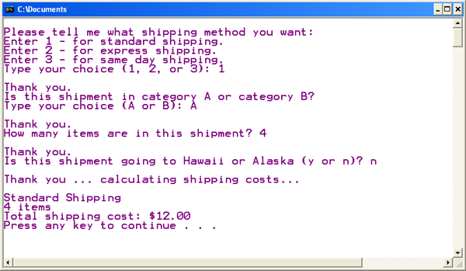

You can get an executable for a Console program as well as one for a GUI program that run correctly on Canvas.